**Pizza Sales SQL Queries**

# KPI’s

**1.Total Revenue:**

SELECT SUM(total_price) AS Total_Revenue FROM pizza_sales;

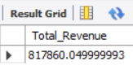

**2. Average order Values**

SELECT SUM(total_price)/COUNT(distinct order_id) AS avg_order_value FROM pizza_sales;

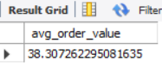

**3. Total Pizzas Sold**

SELECT SUM(quantity) AS Total_Pizza_sold FROM pizza_sales;

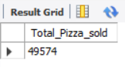

**4. Total Numbers Of Order**

SELECT COUNT( DISTINCT order_id) As total_order FROM pizza_sales;

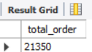

**5. Average Pizzas Per Order**

SELECT ROUND(SUM(quantity)/COUNT(DISTINCT order_id) , 2) AS avg_pizzas_per_order FROM pizza_sales;

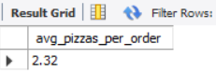

B .DAILY TREND FOR TOTAL ORDERS

SELECT DATE_FORMAT( order_date , '%a') AS order_day , COUNT(DISTINCT order_id) AS Total_orders

FROM pizza_sales

GROUP BY DATE_FORMAT(order_date ,'%a');

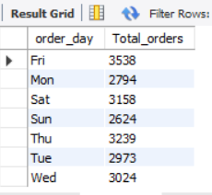

C. Monthly trend for Total orders

SELECT DATE_FORMAT(order_date , '%b') As order_Month , COUNT(DISTINCT order_id) AS Total_orders

FROM pizza_sales

GROUP BY DATE_FORMAT(order_date , '%b')

ORDER BY Total_orders DESC ;

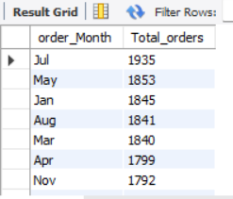

D. Percentage of sales by pizza Category

SELECT pizza_category ,SUM(total_price)AS total_sales, SUM(total_price)*100/(SELECT SUM(total_price) FROM pizza_sales WHERE QUARTER(order_date) = 2) AS PTC

FROM pizza_sales

WHERE QUARTER(order_date) = 2 -- applied fileter but that should also be added in subquery.

GROUP BY pizza_category;

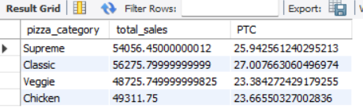

E. Percentage of sales by pizza size

SELECT pizza_size ,ROUND(SUM(total_price),2) AS total_sales, ROUND(SUM(total_price)*100/(SELECT SUM(total_price) FROM pizza_sales WHERE QUARTER(order_date) = 2) , 2) AS PCT

FROM pizza_sales

WHERE month(order_date) = 2 -- applied fileter but that should also be added in subquery.

GROUP BY pizza_size

ORDER BY PCT ;

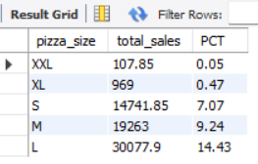

F .Top five best sellers by revenue , total quantity and total orders

SELECT pizza_name , ROUND(SUM(total_price),2) AS Total_Revenue FROM pizza_sales

GROUP BY pizza_name

ORDER BY Total_Revenue DESC

LIMIT 5;

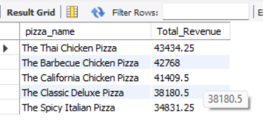

G .Bottom five best sellers by revenue , total quantity and total orders

SELECT pizza_name , ROUND(SUM(total_price),2) AS Total_Revenue FROM pizza_sales

GROUP BY pizza_name

ORDER BY Total_Revenue ASC

LIMIT 5;

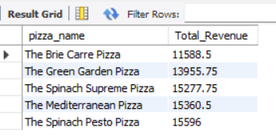

H. Top five best sellers by quantity , total quantity and total orders

SELECT pizza_name , ROUND(SUM(quantity),2) AS Total_quantity FROM pizza_sales

GROUP BY pizza_name

ORDER BY Total_quantity DESC

LIMIT 5;

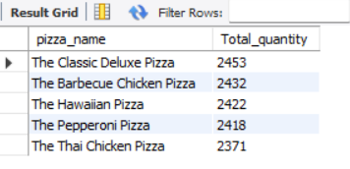

I . Bottom five best sellers by quantity , total quantity and total orders

SELECT pizza_name , ROUND(SUM(quantity),2) AS Total_quantity FROM pizza_sales

GROUP BY pizza_name

ORDER BY Total_quantity ASC

LIMIT 5;

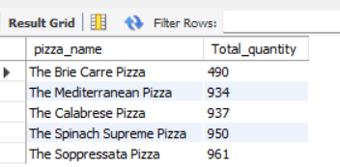

J. Top five best sellers by total orders

SELECT pizza_name , ROUND(COUNT(DISTINCT order_id),2) AS Total_Order FROM pizza_sales

GROUP BY pizza_name

ORDER BY Total_Order DESC

LIMIT 5;

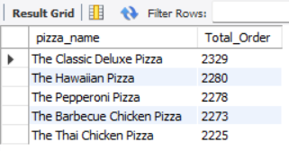

K. Bottom five best sellers by total orders

SELECT pizza_name , ROUND(COUNT(DISTINCT order_id),2) AS Total_Order FROM pizza_sales

GROUP BY pizza_name

ORDER BY Total_Order ASC

LIMIT 5;

